Zeus the poisonous rabbit
Zeus is a rabbit that can poison anything that touches him One day he was out hunting for food. A dog called Hercules came and picked him up by the scruff of the neck. Hercules started to shake him. Luckily he managed to break free and ran away as fast as he could. Then he came to a cave but sadly the cave`s entrance was closed so he had no choice to spit his poisonous venom at Hercules and left him yelping for help. As he slowly melted away into dust Zeus was free from Hercules and went hunting.
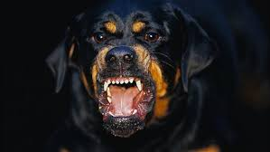

By Laura Smyth

