Litow`s great Escape

Once there was a monster called Litow Stringray. He had ten eyes, big ears, little wings and arms. He seemed fierce but he was not. He was frightened because he lost his mum and dad. One day he went to find his mum and dad but Joker caught him. Joker was not alone. He had evil girls but it was Christmas and Litow Stingray was tied up. Joker also caught Litow’s mum and dad. Litow was sad he could not get free. Litow could not move his stingray but he managed to break free and to get the police.
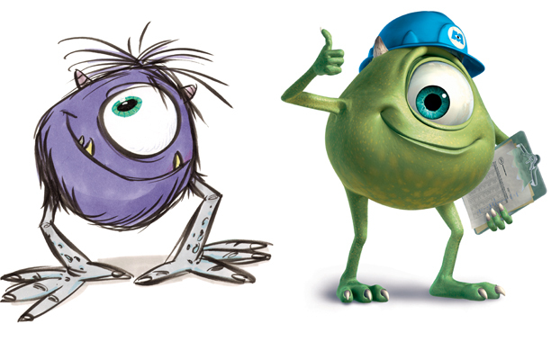 by Tom Wilson

