The Dragon
Bogll is a Dragon he has six eyes and three heads. One day he wanted to break a house and to eat the people up. He stood on the car and drank the oil and diesel which made him sick for a year. He ate a tree and he also ate steel, wood and grass. He ate animal Rod’s school and a town and he was sick for seven years. His birthday was in five weeks from now. Bogll was sad but he was happy that the snow was coming. He burst out of it. He was happy the end.

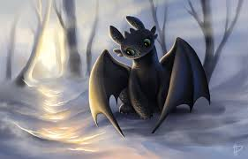By Ben

