One-day Laser was having his blue toast. He got up on his spider legs and walked to the door. He opened it. Snow! He shouted Laser jumped up and down. He looked at the trees. He saw a bird Laser yelled bird! Yetis hate birds. He shot lasers at the birds but the bird dodged all of them he ran into his house he hid under the table but the bird saw him hiding. The bird said his name was Jim and Laser came out and laser came out and they became best friends they couldn’t believe the used to be enemies
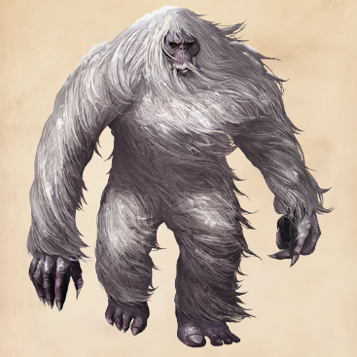

By Robert Boyle

