The Abominable Snowman.
The Abominable Snowman was sleeping in his cave when he heard a noise. “I wonder who that is, they could be my breakfast!” he said. So he went out of his cave and saw some mountaineers. They saw him and ran away screaming. The Abominable Snowman was very hungry, so he ran after them. Since he took much bigger steps than they did he soon caught up. He grabbed them, put them on his back, and brought them back to his cave. Then he got a knife and fork and gobbled them up in a flash. Then he was full.
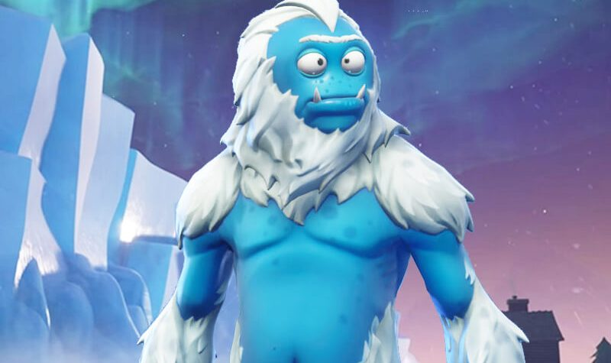
By Noah Graham.

