Fangdom’s fight
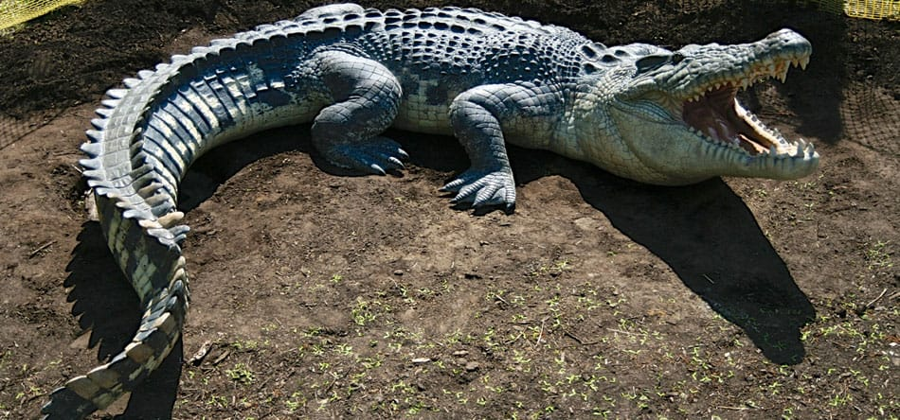
Fangdom was swimming around the deep blue sea gobbling up some little fish with his crocodile mouth and his blue skin. He turned around and saw a crocodile and a shark. “Do you want a fight?” said the shark. Fangdom told them to look away. So they did. Then he camouflaged to blend in.” where did he go? ” said the shark “I don’t know, ”replied the crocodile . A big whale went behind Fangdom and the shark saw him. The shark and the crocodile started to fight him. So he grew fangs all over his body and stabbed the shark

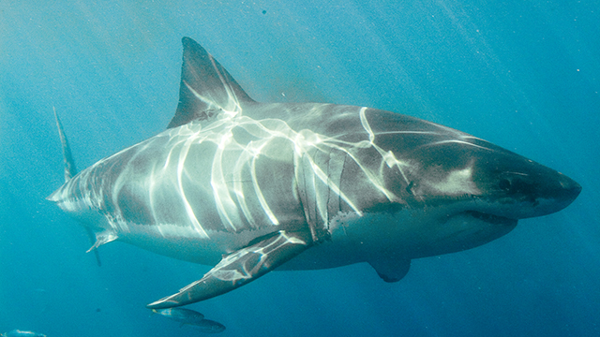
By Finn Montgomery

