France’s Adventure

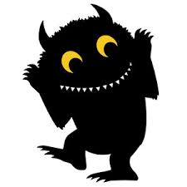
France, the tiny alien with no arms, can camouflage to any colour. One day he had a crazy idea he was going to go to the gym, but when he got there he took the wrong path. France went to the swimming pool instead of the gym, he hated water. France didn’t want to be seen so he camouflaged to the colour of the wall. Then he quickly found the exit of the swimming pool. He opened it and ran out as fast as he could then he opened the door of the building and into the cold cold snow.

By Alison Douglas

